* Object
* Browser Object Model(BOM)
  + Window Object
  + Navigator Object
* Document Object Model(DOM)
  + Document Object

==================================================================

**Object**

A javaScript object is an entity having state and behavior (properties and method).

Ex: car, pen, table, desktop, etc.,

JavaScript is template based not class based. Here, we don't create classes to get the object. But, we directly create objects.

Every web page resides inside a browser window which can be considered as an object.

The BOM (Browser Object Model) consists of the objects navigator, history, screen, location and document which are children of window. In the document node is the DOM (Document Object Model), the document object model, which represents the contents of the page. You can manipulate it using javascript.

**Browser Object Model (BOM)**

Browsers feature a Browser Object Model that allows access and manipulation of the browser window. Using the BOM, developers can move the window, change text in the status bar and perform other actions that do not directly relate to the page content

The BOM is the **Browser** Object Model, which deals with browser components aside from the document, like history, location, navigator and screen (as well as some others that vary by browser).

**1. Window object**

Top of the hierarchy. It is the outmost element of the object hierarchy.

The default object of the browser is window means you can call all the functions of window by specifying window or directly.

The window object is supported by all browsers. It represents the browser's window.

All global JavaScript objects, functions, and variables automatically become members of the window object.

Global variables are properties of the window object.

Global functions are methods of the window object.

**For example**: window.alert("hello javascript"); is same as alert("hello javascript");

# 

# You can use a lot of properties (other objects) defined underneath the window object like document, history, screen, navigator, location, innerHeight, innerWidth,

# 

Even the document object (of the HTML DOM) is a property of the window object:

**window.document.getElementById("header");**

is the same as:

**document.getElementById("header");**

**2. Navigator Object**

The JavaScript Navigator provides information about the web browser and its capabilities. You can reference the Navigator object via the read-only window.navigator property.

The Navigator object has properties that convey the browser’s information. It can be used to get browser information such as appName, appCodeName, userAgent etc. For example, the userAgent is a property of the window.navigator object. It is a long string that identifies the web browser.

Here is an example demonstrates navigator object properties in JavaScript:

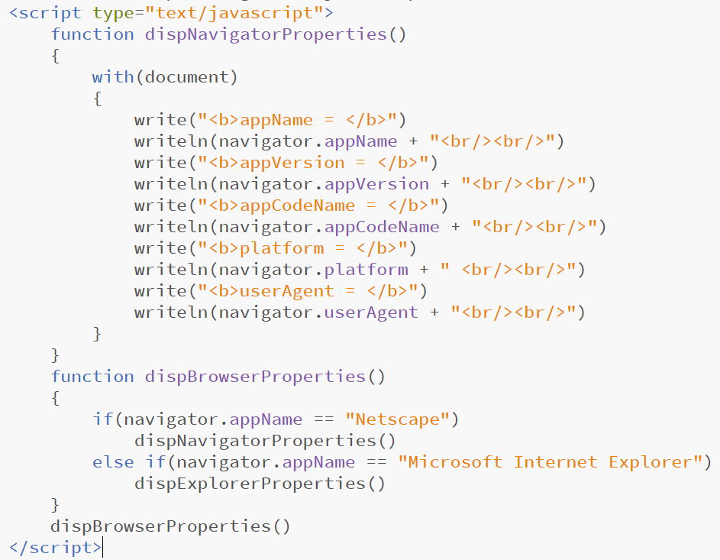

Here are some outputs of the above JavaScript navigator object properties example code. This is the snapshot of output produced in **Google Chrome** browser:

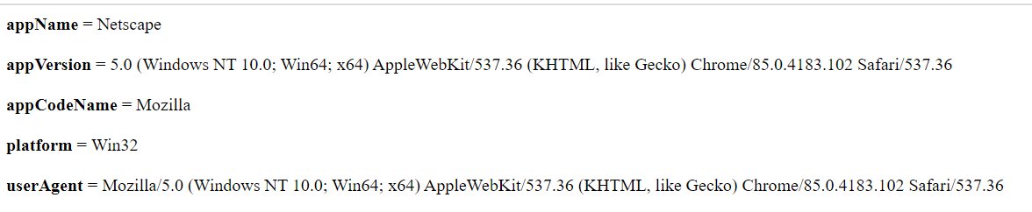

**Navigator Object Hierarchy**

When you load a document in Navigator, it creates a number of JavaScript objects with property values based on the HTML in the document and other pertinent information. These objects exist in a hierarchy that reflects the structure of the HTML page itself. The following figure illustrates this object hierarchy.

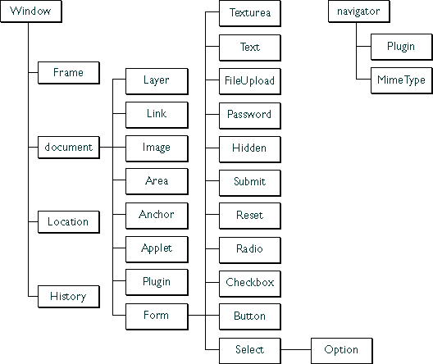

**Document Object Model(DOM)**

The DOM is the **Document** Object Model, which deals with the document, the HTML elements themselves, e.g. document and all traversal you would do in it, events, etc.

A Document object represents the HTML document that is displayed in that window. The Document object has various properties that refer to other objects which allow access to and modification of document content.

The way a document content is accessed and modified is called the Document Object Model, or DOM. The Objects are organized in a hierarchy. This hierarchical structure applies to the organization of objects in a Web document.

**3. Document Object**

Document object − Each HTML document that gets loaded into a window becomes a document object. The document contains the contents of the page.

**Properties of DOM**



1. **Window Object:** Window Object is always at the top of the hierarchy.
2. **Document object:** When an HTML document is loaded into a window, it becomes a document object.
3. **Form Object:** It is represented by ***form*** tags.
4. **Link Objects:** It is represented by ***link*** tags.
5. **Anchor Objects:** It is represented by ***a href*** tag.
6. **Form Control Elements:**: Form can have many control elements such as text fields, buttons, radio buttons, and checkboxes, etc.

***Methods* of Document Object**:

1. **write(“string”):** writes the given string on the document.
2. **getElementById():** returns the element having the given id value.
3. **getElementsByName():** returns all the elements having the given name value.
4. **getElementsByTagName():** returns all the elements having the given tag name.
5. **getElementsByClassName():** returns all the elements having the given class name.